Foundations of Programming
Assignment No. 21: File Copy Using File Handling
Problem Statement
Write a C program to copy contents of one file to another using file handling functions.
Algorithm
Step 1: Start
Step 2: Open source file 'source.txt' in read mode using fopen()
Step 3: If file cannot be opened, display error and exit
Step 4: Open destination file 'destination.txt' in write mode using fopen()
Step 5: If file cannot be opened, display error, close source, and exit
Step 6: Read each character from source using fgetc() until EOF
Step 7: Write each character to destination using fputc()
Step 8: Close both files using fclose()
Step 9: Display 'File copied successfully'
Step 10: Stop
Flowchart (Text Representation)
START → Open source.txt (read mode)
→ [Opened?] → NO → Print error → EXIT
→ YES → Open destination.txt (write mode)
→ [Opened?] → NO → Print error → Close src → EXIT
→ YES → ch = fgetc(src)
→ [ch != EOF?] → YES → fputc(ch, dest) → Read next char
→ NO → Close both files → Print 'File copied successfully' → STOP
C Program Code
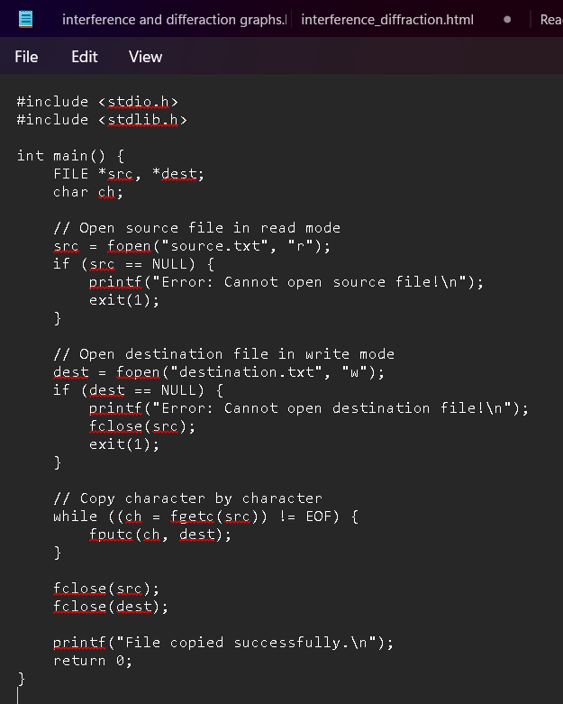
Sample Input / Output
source.txt contains: Hello / Welcome to C Programming
Output: File copied successfully.
destination.txt will contain the same content as source.txt

